Parent to Parent
Job Description

Job title | Young Persons’ Advocacy Worker (Dundee)  Term time post – Maternity Cover

We are looking to appoint a Young Persons’ Advocacy Worker (Maternity Cover) who will provide support to children and young people who have additional needs and/or behavioural problems. They will also provide advocacy at meetings e.g. school reviews, children’s hearings etc. The successful candidate will develop the service in mainstream and special schools. They will be required to work during term time.

Working from home, the successful candidate will liaise closely with the office staff to ensure the smooth running of the project. S/he must be self-motivated, flexible, sensitive and have good organisational skills. A valid driving licence and use of a car is essential. A background in advocacy or working with young people is desirable and experience of additional needs is essential.
This post is subject to a P.V.G. check.

DUTIES:

- To build a relationship with the young people with additional needs (including complex disability).
- To provide a listening ear and offer supporting strategies to help them understand and manage their anxieties
- To offer appropriate support e.g. preparation for meetings
- To enable the young person to voice their views/fears and to speak for them if necessary.
- To build strong links with voluntary and statutory services including the child protection team.
- Support the young people to connect with their local community networks
- To build a relationship with the young people, help them to voice their concerns and support them to identify solutions to issues that are affecting them.
- To develop, co-ordinate and facilitate in school peer advocacy group work within a range of primary and high schools in Dundee to a small group of young people on a termly basis – in line with In-school scoping paper outcomesTo make appropriate links with schools.
- To make links with families as appropriate.
- To keep accurate and up to date records.
- To attend regular support and supervision sessions.
- To attend regular team meetings

Organisational position
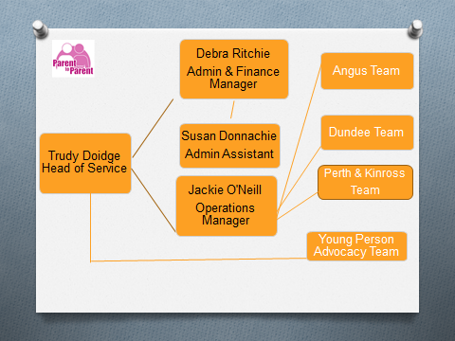

Knowledge, training and experience required
Qualifications
Specific formal qualifications are not essential but relevant qualifications e.g. social care, child care, community learning, nursing, mental health are desirable. A full driving license and use of a car is essential
Experience - essential
- Experience of children with additional needs
- Experience of working with children with challenging behaviour
- Experience of partnership working
Experience – desirable
- At least 2 years’ experience working with children and young people
- Experience of working in a small remote team
- Experience of working with vulnerable families
- Experience of facilitating groups
Skills - essential
- Ability to work on own initiative
- Good track record of establishing positive working relationships
- Good oral communication skills
- Good organisational skills
- IT skills
- Ability to work under pressure
Knowledge - essential
- Understanding the need for advocacy
- Good knowledge understanding of child protection, adult protection and data protection.
- Good knowledge and understanding of the GIRFEC guidance and the Children & Young People Act
Knowledge – desirable
- Familiarity with Additional Support for Learning Act
General
- This post is subject to PVG Membership.
- Business insurance for your vehicle is an essential requirement of the post

Demands of the job

- The post-holder may have to support young people experiencing crises.
- Confidentiality, diplomacy and discretion are required at all times.
- Occasionally support young people in distress and experience distressing situations

Decisions and judgements

The post-holder will
- Work on their own initiative at times.
- manage changing demands, making necessary changes to respond to crisis situations
- Identify when issues should be referred to Head of Service.

Most challenging aspects of the job

- Exposure to young people experiencing emotional difficulties.
- The need to change plans and meet demands at short notice

Other information

Salary: £20,903 pro rata
Hours: 20 hours per week
Line managed by: Head of Service
Place of work: Dundee area
Annual Leave: 4 weeks and 11 public holidays (pro rata)
Contract: Term time

